**LAB 10 : a. Setup Laravel project (Book Inventory).**

**Solution:**

Step 1: Visit the following URL and download composer to install it on your system

**https://getcomposer.org/download/**

Step 2: After the Composer is installed, check the installation by typing the Composer

command in the command prompt as shown in the following screenshot

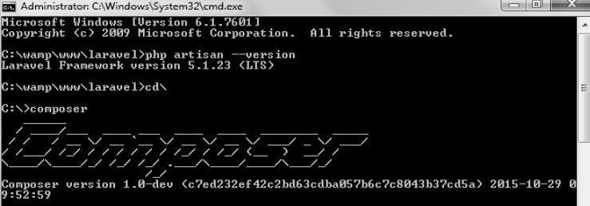

Step 3: Create a new directory anywhere in your system for your new Laravel project. After

that, move to path where you have created the new directory and type the following command

there to install Laravel. 

Step 4: The above command will install Laravel in the current directory. Start the Laravel

service by executing the following command.

**php artisan serve**

Step 5: After executing the above command, you will see a screen as shown below

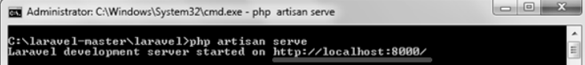

Step 6: Copy the URL underlined in gray in the above screenshot and open that URL in the browser. If you see the following screen, it implies Laravel has been installed successfully.

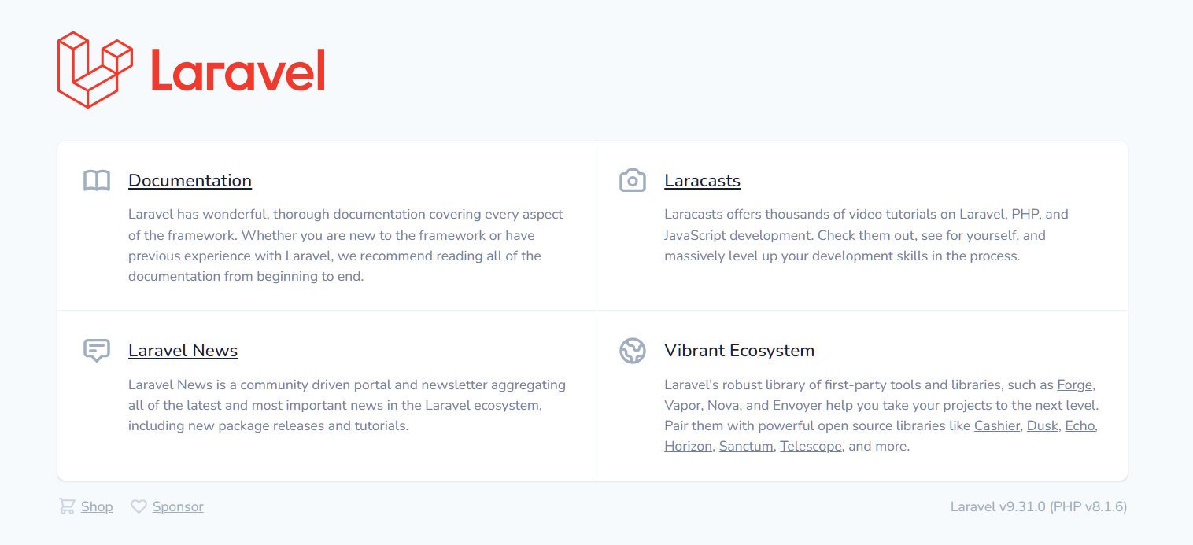

**b. Setup the database in Laravel.**

Step 1 : Create new database name : book_inventory

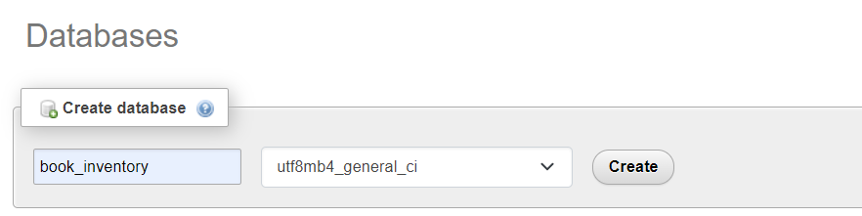

Step 2 : Now Edit the .env file in the directory

DB_CONNECTION=mysql

DB_HOST=127.0.0.1

DB_PORT=3306

DB_DATABASE=book_inventory

DB_USERNAME=admin

DB_PASSWORD=admin

**c. Implement Select Operation in Laravel with GUI**

**View.blade.php Output:**

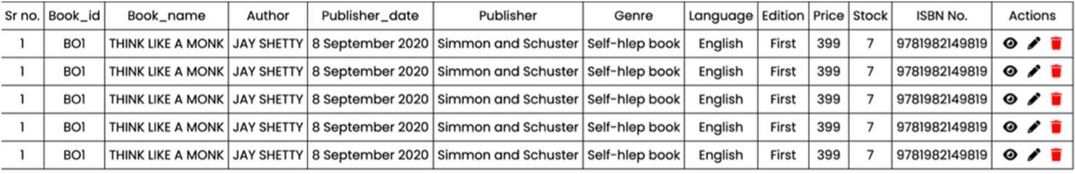

**Code :**

<!DOCTYPE html>

<html lang="en">

<head>

<meta charset="UTF-8">

<meta http-equiv="X-UA-Compatible" content="IE=edge">

<meta name="viewport" content="width=device-width, initial-scale=1.0">

<title>View</title>

<link rel="stylesheet" href="https://cdnjs.cloudflare.com/ajax/libs/font- awesome/6.2.0/css/all.min.css" integrity="sha512- xh6O/CkQoPOWDdYTDqeRdPCVd1SpvCA9XXcUnZS2FmJNp1coAFzvtCN9BmamE+4aHK8yyUHUSCcJH gXloTyT2A==" crossorigin="anonymous" referrerpolicy="no-referrer" />

<link href="{{ URL::asset('css/view.css') }}" rel="stylesheet" type="text/css" > @include('link')

</head>

<body> @include('navbar')

<table style="margin-top: 30px">

<tr>

<td>Book_id</td>

<td>Book_name</td>

<td>Author</td>

<td>Publisher_date</td>

<td>Publisher</td>

<td>Genre</td>

<td>Language</td>

<td>Edition</td>

<td>Price</td>

<td>Stock</td>

<td>ISBN No.</td>

<td>Actions</td>

</tr>

@foreach($data as $data)

<tr>

<td>{{$data->book_id}}</td>

<td>{{$data->name}}</td>

<td>{{$data->author}}</td>

<td>{{$data->date}}</td>

<td>{{$data->publisher}}</td>

<td>{{$data->genre}}</td>

<td>{{$data->language}}</td>

<td>{{$data->edition}}</td>

<td>{{$data->price}}</td>

<td> {{$data->stock}}</td>

<td>{{$data->isbn}}</td>

<td>&nbsp;

<a href="{{'/details/'.$data->id}}"><i class="fa-solid fa-eye"></i></a>&nbsp;&nbsp;

<a href="{{'/edit/'.$data->id}}"><i class="fa-solid fa-pen-fancy"></i></a>&nbsp;&nbsp;

<a href="{{'/delete/'.$data->id}}" id="delete"><i class="fa-solid fa-close" style="font-size: 20px"></i></a>&nbsp;&nbsp;

</td>

</tr> @endforeach

</table> @include('footer')

</body>

</html>

# Create BookController:

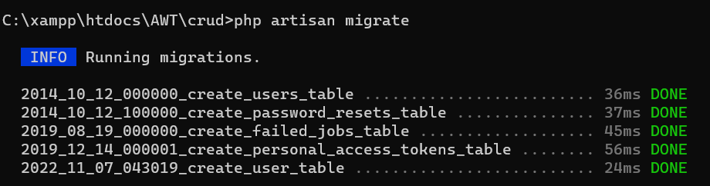

**Code:**

<?php

namespace App\Http\Controllers; use App\Models\Book;

use Illuminate\Http\Request;

use Illuminate\Support\Facades\DB; use Throwable;

class BookController extends Controller

{

public function index(){

$data = Book::all();

return view('view',['data'=>$data,]);

}

}

# Route:

Route::get('/dbsel',[BookController::class,'index']);